From: Morris, Jeffrey <xxxx>
Sent: Tuesday, July 16, 2024 2:23 PM
To: Steve Kirsch <xxxx>; Morris, Jeffrey <xxxx>
Subject: Re: [External] FW: URGENT: I'm going to publish this story at 4pm PST today comparing Pfizer / Moderna / Novavax vaccines
As usual, your analysis is simplistic and interpretations invalid.
For one thing, you ignore the significantly different age distribution of Pfizer and Moderna vaccinated.
From your spreadsheet, I computed the % in each age group 0-1yr, 1-5yr, 5-10yr, …, 90-95yr, >95yr for Pfizer and Moderna, and they differed a lot (see bar plot below)
Then I got age specific death rates (per 1 million per year) based on 2015-2019 averages for these age groups from https://www.mortality.org/Country/HCDCountry?cntr=CZE (see black line below)
It is then easy to compute the expected death rate for the Pfizer and Moderna age cohorts by simply multiplying the % in each age group by the respective background death rates for each age group and adding up.
When this is done, the Pfizer group, which is younger demographic, has expected background death rate of 13,915 deaths per million
The Moderna group, which is older, has expected death rate of 22,045 deaths per million, which is almost 60% greater than the Pfizer group.
So even if there was no other differences between Moderna and Pfizer groups, and no vaccine effect whatsoever, we’d expect Moderna death rate to be ~60% higher than Pfizer in this cohort.
And that is just one major factor – there of course are many other factors that can differ across groups – including time frame, comorbidities, number of doses, etc. that may come into play.
As usual, you jump to conclusions like the Boy who Cried Wolf, desperate to somehow feed your narratives of vaccine-caused deaths.

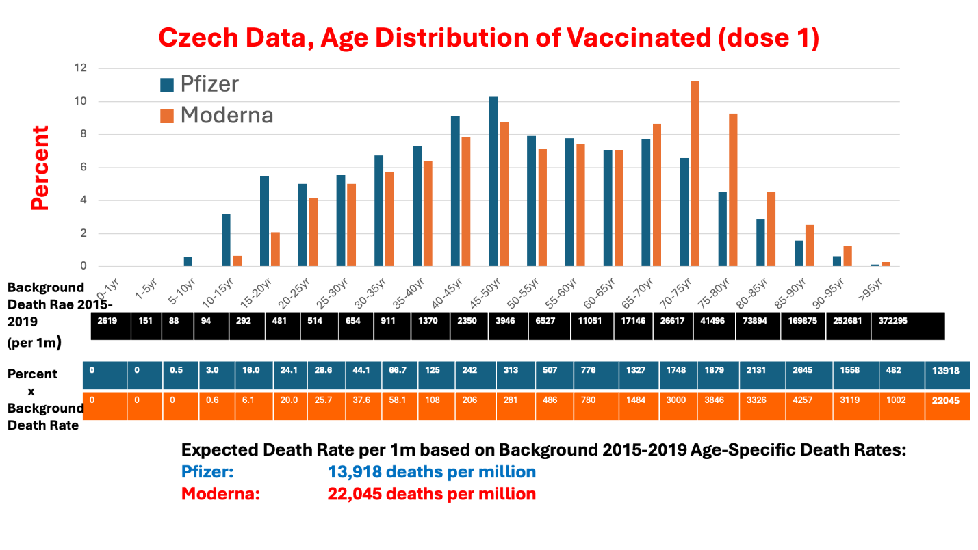
Jeffrey S. Morris, PhD
George S. Pepper Professor of Public Health and Preventive Medicine
Professor of Biostatistics
Director, Division of Biostatistics
Department of Biostatistics, Epidemiology and Informatics
Perelman School of Medicine
Professor of Statistics and Data Science
The Wharton School
University of Pennsylvania
600 Blockley Hall, 423 Guardian Drive
Philadelphia, PA 19104-6021
Covid-19 Data Science Blog: http://covid-datascience.com
https://works.bepress.com/jeffrey_s_morris/
https://scholar.google.com/citations?user=neVkiWoAAAAJ&hl=en
@jsm2334
Area Editor, Biology, Medicine and Genomics for The Annals of Applied Statistics

From: Steve Kirsch <xxx>
Date: Tuesday, July 16, 2024 at 1:15 PM
To: Morris, Jeffrey <xxx>
Subject: [External] FW: URGENT: I'm going to publish this story at 4pm PST today comparing Pfizer / Moderna / Novavax vaccines
You're mentioned in the article. Any comments on how this is wrong?
-----Original Message-----
From: Steve Kirsch
Sent: Tuesday, July 16, 2024 10:12 AM
To: media@modernatx.com; media@novavax.com
Cc: Livio Sanchez
Subject: URGENT: I'm going to publish this story at 4pm PST today comparing Pfizer / Moderna / Novavax vaccines
Importance: High
If you want to comment on it, please call me ASAP at 650-279-1008 so I can include your comments before the story goes public at 4pm PST.
I have 1M readers so this will have big impact. Tucker Carlson will be promoting this as well.
This is the NON-PUBLIC link to the article to be published:
xxxx
Thank you.

From: Morris, Jeffrey <xxx>
Sent: Tuesday, July 16, 2024 5:54 PM
To: Steve Kirsch <xxx>
Subject: Re: [External] FW: URGENT: I'm going to publish this story at 4pm PST today comparing Pfizer / Moderna / Novavax vaccines
Just did a Quick Look on the train
The age distribution factor is not a major issue for your analyses done by age group but it shows how dramatically different the age demographics of the small subset (9.4% of size of Pfizer) which demonstrates that in spite of your (false) claim in the article and talk the Moderna and Pfizer are not equivalent in every way except vaccine type — you can’t get around confounding and age is not the only confounder.
Funny you say others waive their hands but nearly all your arguments are hand waving…
1. HVE lasts exactly 3 weeks
2. Any increase after that is sign of unsafe vaccine killing people (even when the death rates are still below baseline rates like they were for your Nee Zealand data)
3. Safe vaccines have flat profiles over time
4. If vaccines were safe they’d all have same death rates (assumes zero confounding which is known to be wrong). You also do this with Novavax comparison.
5. You claim any difference between vaccines means “vaccines are killing people”
6. Your “Bradford Hill” arguments are handwaives
You also argue that because there is no known systematic confounding bias between vaccines therefore there must be none and they are comparable which is invalid bass-ackwards logic
I won’t even get into how you switch your claims of when vaccines kill from day of vaccine to weeks after to 3 months later to 6 or more months later in contradictory ways (eg acknowledging death rates much lower in first 3 weeks than unvaccinated yet arguing many deaths immediate following vaccination in VAERs and anecdotes.
I also won’t get into how your insurance data discussion ignores the delta surge and fact these deaths were concentrated in lowest vaccinated southeastern states and how regardless of your claims about “mandates” we know how many young adults were vaccinated each month and the vast
Majority were vaccinated in spring and very few in Q3 as I’ve written about as nauseum
And I won’t get j. To your gish gallop repeating of your select anecdotes and flawed interpretations of nursing home data. We’ve been through that before.
Your ignoring of large number of Covid deaths is also huge blind spot for you
Also btw these data have unvaccinated data for dead and not — it is weak sauce to not even look at that and assume that it is “undercounting unvaccinated” — that is a problem for various dashboard analyses but if the data are what you say they are including everyone alive during that time period then this is not a problem for these data. Your refusal to plot it strongly suggests it shows unvaccinated death rates are higher than all vaccine groups which blows your whole argument out of the water.
Would be at least worth looking at, and comparing that and vaccination group death rates with background death rates by age in Czech Republic from actuarial data.
If I can find time I’ll do some of my own analyses of this and the Italian data. We see the same patterns in all these data sets that we saw in Uk and Hungarian data.
Regards
Jeff
Sent from my iPhone

